**Introduction to Computer Hardware**

Mother Board

The motherboard is defined as a circuit board for the computer system, also called logic board or mainboard. In the computer system, the biggest component is the motherboard that controls all the components of the computer system and establishes a link between all components. From the motherboard, different components like ROM, CPU, RAM, PCI slots, USB ports, and other components are connected. The controller’s device is also attached to the motherboard like DVD< hard drive, mouse, and keyboard. The computer system starts using the motherboard and these components act as the backbone for starting the system.

**Components of Motherboard**

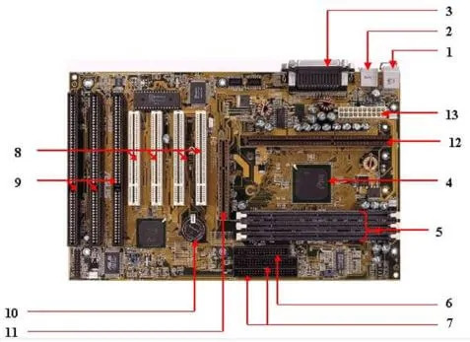

#### 1. Keyboard and mouse

There are mainly 2 types of mouse and keyboard connectors. The first connector is known as PS/2 & the second connector is known as USB.

#### **2. Universal Serial Bus (USB)**

The USB port is used for connecting the computer system. In the computer system, there is various type of devices that are connected with the USB port like keyboard, mouse, camera, scanner, printers, and another device. The main use of a USB port is to connect the peripheral devices and computer motherboards. The peripheral device connected to the computer system can be inserted or remove without system restarts that can be the main advantage of a USB port.

#### 3. Parallel port

The old printers that are used in past use the parallel port to connect with the computer system. In the parallel port, multiple wires are used to send or receive multiple bits of the data in a single instance. On the other hand, serial ports use only one wire at a time.  In the parallel port, 25 pins female DB type connector is used.

#### 4. CPU chip

The central processing unit is the processor that controls all the functions of the computer system. The overall flow of task and functions are controlled by the central processing unit. For the computer system, the central processing unit is called the brain of the computer system.

#### 5. RAM slots

The RAM slots are used for connecting the RAM (memory) in the computer system. In the general computer system, there are mainly two RAM slots but sometimes there can be four-plus slots in the motherboard to increase the memory of the computer system.

#### 6. Floppy Controller

The older motherboard chip contains a 34-pin type ribbon cable for connecting the computer system with a floppy drive. In this ribbon cable, one end is directly connected with the computer system and one end is connected with the motherboard.

#### 7. IDE controller

The integrated drive electronics are also known as ATA or Parallel ATA. The IDE is the type of component that issued for hard drive control. In today’s computer system, the IDE controller supports is not supported.

#### 8. PCI slot

The full form of PCI is a peripheral component interface. The PCI slot is mainly used to insert the expansion cards on the computer. The other PCI devices can also be connected like a sound card, network card, video, card, modems, and other device3s. In today’s computer system support for PCI expansion slots are not there.

#### 9. ISA slot

Industry-standard architecture (ISA) is defined as standard architecture for expansion bus. The ISA slot issued for connecting input devices and modems.

#### 10. CMOS Battery

The CMOS battery is used for storing the BIOS settings on the motherboard. The CMOS battery is also capable of storing the time and data in it.

#### 11. AGP slot

AGP (Accelerated Graphics slot) is a type of computer slot that is used for attaching the video card to the system. This slot is a high-speed slot so that data transfer can be done at high speed.

#### 12. CPU slot

The CPU slot is a type of port that is used to connect the central processing unit to the motherboard of the computer system.

#### 13. Power supply slot

The power supply slot is used for providing the electric supply to the computer system so that it can start and perform its functions. The total power supply given to the system is around 110 ac power. In the power supply type connector, there are a total of 20-pins that are used to maintain the power supply to the computer system.

### Factors of Motherboard

The main form factor for the motherboard is size and shape. The other factors are physical layout, mounting holes, and board organization.

In the below section, some of the form factors are mentioned below:

#### 1. ATX

In this type, the standard locations were defined for mouse, keyboard, input/output devices, video connectors, and other devices. In the year 1990, the ATX form factor was developed. The expansion slot given new location as in this form factor expansion slot were given separate space so that they can be connected with the motherboard.

#### 2. Micro-ATX

The benefit obtained from the Micro-ATX is the same as from the ATX form factor. The main difference is an improvement in system design so that the overall cost of the component can be reduced as the size of the motherboard is reduced in this form factor. The size is reduced by reducing the I/O slots number on the motherboard.

### Uses of Motherboard

The motherboard is the main component in the computer system that is used for connecting all the components of the computer system so that they can perform several tasks and functions in the system. The motherboard is considered as the spine of the system as all components are connected to a single circuit board for performing their functions. The motherboard is a costly device and once it gets damaged the user needs to spend a lot of money to buy a new motherboard for a computer system. The motherboard is a central device where all devices are get connected and maintain the flow in the computer system.

Ram Modules

## **memory module**

A narrow printed circuit board that holds memory chips (RAM chips). The common architecture for desktop computers is the dual in-line memory module (DIMM), which transfers 64 bits at a time. Because of space limitations, laptops use small outline DIMMs (SODIMMs). The modules are keyed with notches in different places so they cannot be inserted into the wrong slots (see below). See [**RAM**](https://encyclopedia2.thefreedictionary.com/RAM).  
  
**Error Detection and Correction**  
Most desktop and laptop computers use RAM chips that hold eight bits per byte, while high-end servers and workstations typically have nine bits. The ninth bit is a parity bit for detecting errors. See [**ECCmemory**](https://encyclopedia2.thefreedictionary.com/ECC+memory) and [**RDIMM**](https://encyclopedia2.thefreedictionary.com/RDIMM).  
  
**Upgrading Memory - Read the Manual (RTFM!)**  
A single DIMM can often be used, but pairs of DIMMs increase performance in machines that support dual channel DDR SDRAM. When upgrading memory, read the motherboard manual to find out which module combinations can be used. See [**MT/sec**](https://encyclopedia2.thefreedictionary.com/MT%2fsec), [**SDRAM**](https://encyclopedia2.thefreedictionary.com/SDRAM), [**memory types**](https://encyclopedia2.thefreedictionary.com/memory+types), [**memory card**](https://encyclopedia2.thefreedictionary.com/memory+card) and [**Hybrid Memory Cube**](https://encyclopedia2.thefreedictionary.com/Hybrid+Memory+Cube)

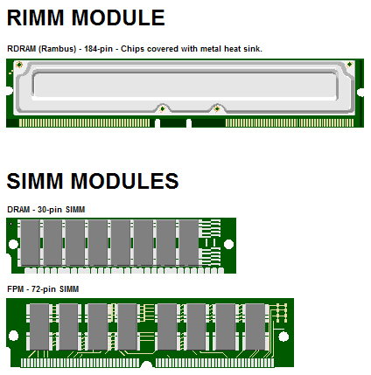

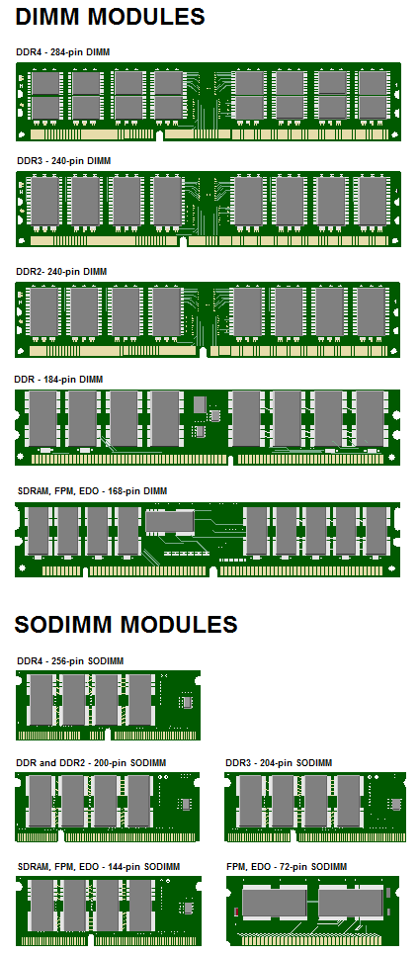

|  |
| --- |
| **DIMM Modules in a Desktop Machine** |
| To change memory in desktop computers, the cabinet has to be opened. Two of the three DIMM slots on this Mac motherboard are empty |

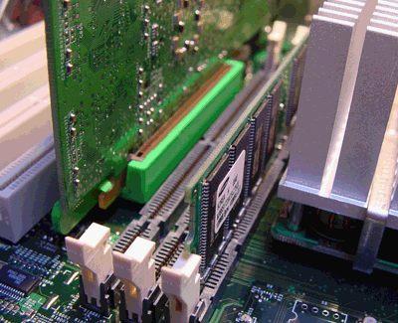

|  |
| --- |
| **Laptop Memory (SODIMMs)** |
| To change laptop RAM, a cover plate on the bottom of the unit typically has to be unscrewed |

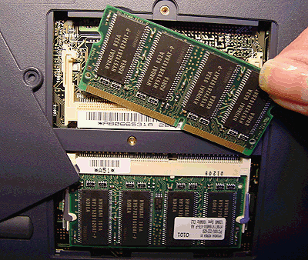

|  |
| --- |
| **Two Sticks of Memory** |
| RAM modules are often called "sticks" because they are housed on long, thin circuit boards. |

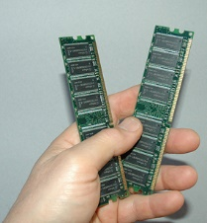

Daughter Card

A daughtercard or [**daughterboard**](https://www.easytechjunkie.com/what-is-a-daughterboard.htm) is a type of [**circuit board**](https://www.easytechjunkie.com/what-is-a-circuit-board.htm) that gets added to an existing one. Its name is appropriate for its use, since it is connected to a “[**motherboard**](https://www.easytechjunkie.com/what-is-a-motherboard.htm)” or “main board.” The motherboard is the primary circuit board for a device. It is usually in the device as it is shipped from the factory. A daughtercard may be added later.

Some daughtercard designs are made so that engineers can add functionality to a device without requiring a lot more room inside its housing. These kinds of items are often called riser boards or risers. Some might also call them “mezzanine boards.”

Daughtercards are different from some other types of additional circuit boards that tech enthusiasts call “expansion cards.” In expansion cards, the circuit board is often plugged in through a gap in the housing of a computer or device. These expansion boards help to give a device more functionality, often for additional sound play or for better visuals on a high-tech monitor or screen.

In contrast to the way expansion boards are used, a daughtercard can be a more fundamental enhancement for a device. Adding a daughtercard often requires getting into the guts of a device. That’s why some users might hire a professional to install it. Companies that make an electronic device might offer a daughtercard as part of an essential upgrade that allows the product to be used in more various ways.

With the rise of connective USB ports and other technology, it has become less necessary to upgrade devices with daughtercards or daughterboards. A lot of advanced use can be built into a wireless connection and “outsourced” to a remote server, rather than adding it physically into a desktop or laptop computer. However, some types of equipment might still get these kinds of additions as provided by the manufacturer. Computer and electronics makers choose the best ways of offering upgrades that they feel will match the needs and desires of their customer base. Since not a lot of laptop or computer users want to wrestle a daughtercard into an existing circuit board design, companies that sell to a consumer market will probably choose alternatives, or offer professional installation as a free service if they are offering a daughtercard as a way to upgrade a device.



Bus Slots

An expansion slot is a socket on the motherboard that is used to insert an expansion card (or circuit board), which provides additional features to a computer such as video, sound, advanced graphics, Ethernet or memory.

The expansion card has an edge connector that fits precisely into the expansion slot as well as a row of contacts that is designed to establish an electrical connection between the motherboard and the electronics on the card, which are mostly integrated circuits. Depending on the form factor of the case and motherboard, a computer system generally can have anywhere from one to seven expansion slots. With a backplane system, up to 19 expansion cards can be installed.

## SMPS

The full form of SMPS is **Switched Mode Power Supply** also known as **Switching Mode Power Supply**. SMPS is an electronic power supply system that makes use of a switching regulator to transfer electrical power effectively. It is a PSU (power supply unit) and is usually used in computers to change the voltage to the appropriate range for the computer.

An SMPS adjusts output voltage and current between different electrical configurations by switching the basics of typically lossless storage such as capacitors and inductors. Ideal switching concepts determined by transistors controlled outside of their active state that have no resistance when ‘on’ and carry no current when ‘off.’ It is the idea why switches with an ideal function will operate with 100 per cent output, that is, all input energy is provided to the load; no power is wasted as dissipated heating. In fact, such ideal systems do not exist, which is why a switching power source can not be 100 per cent proficient, but it is still a vital improvement in effectiveness over a linear regulator.

## **Working principles of SMPS**

In the SMPS device, the switching regulators are used which switches on and off the load current to maintain and regulate the voltage output. Suitable power generation for a system is the mean voltage between off and on. Unlike the linear power supply, the SMPS carry transistor switches among low dissipation, full-on and full-off phase, and spend much less time in high dissipation cycles, which decreases depleted strength.

### Benefits of SMPS

* The switch-mode power source is small in scale.
* The SMPS is very lightweight.
* SMPS power consumption is typically 60 to 70 per cent, which is ideal for use.
* SMPS is strongly anti-interference.
* The SMPS production range is large.

### Limitations of SMPS

* The complexity of SMPS is very large.
* The production reflection is high and its control is weak in the case of SMPS.
* Use of SMPS can only be a step-down regulator.
* In SMPS, the voltage output is just one.

## Internal Storage Devices

Some storage devices are classed as 'internal' which means they are inside the computer case.

Most computers have some form of internal storage. The most common type of internal storage is the hard disk.

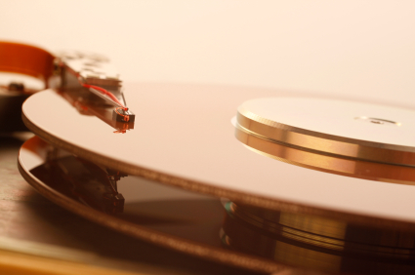

At the most basic level, internal storage is needed to hold the operating system so that the computer is able to access the input and output devices.

It will also be used to store the applications software that you use and more than likely, the original copies of your data files.

Internal storage allows the data and applications to be loaded very rapidly into memory, ready for use. The data can be accessed much faster than data which is stored on an external storage device. This is because internal storage devices are connected directly to the motherboard and its data bus whereas external devices are connected through a hardware interface such as USB, which means they are considerably slower to access.

Internal storage also means that if the computer is moved around, it will still retain its most commonly used data.

The main disadvantage of internal storage is that when the hard disk fails (and it will), all the data and applications may be lost.

This can be avoided to some extent by using more than one hard disk within the machine. Each hard disk has a copy of all the data, so if one fails the other can carry on. This is called a RAID array. An alternative is to use external drives for backup.

Interfacing Ports

A computer is a device that transforms data into meaningful information. It processes the input according to the set of instructions provided to it by the user and gives the desired output. As we know that we can connect multiple external devices with the computer system. Now, these devices are connected with the computer using Ports. The ports are the physical docking points present in the computer through which the external devices are connected using cables. Or in other words, a port is an interface between the motherboard and an external device of the computer. There are different types of ports available:

* Serial port
* Parallel port
* USB port
* PS/2 port
* VGA port
* Modem port
* FireWire Port
* Sockets
* Infrared Port
* Game Port
* Digital Video Interface(DVI) Port
* Ethernet Port

Server and desktop Class Computers

Many people mistakenly believe that a [server](https://www.webopedia.com/definitions/server/) is no different from a typical [desktop computer](https://www.webopedia.com/definitions/desktop-computer/). This couldn’t be further from the truth. While almost any computer that meets the minimum hardware requirements can run a server operating system that alone does not make a desktop computer a true server. Even if the desktop computer had similar processor speeds, memory and storage capacity compared to a server, it still isn’t a replacement for a real server. The technologies behind them are engineered for different purposes.

A [desktop computer](https://www.webopedia.com/definitions/desktop-computer/) system typically runs a user-friendly operating system and desktop applications to facilitate desktop-oriented tasks. In contrast, a [server](https://www.webopedia.com/definitions/server/) manages all network resources. Servers are often [dedicated](https://www.webopedia.com/definitions/dedicated/) (meaning it performs no other task besides server tasks). Because a server is engineered to manage, store, send and process data 24-hours a day it has to be more reliable than a desktop computer and offers a variety of features and hardware not typically used in the average desktop computer.

## SERVER HARDWARE

One of the best choices for a small business is a [dedicated server](https://www.webopedia.com/definitions/dedicated-server/) built from the ground up as a file server to provide features and expansion options that a [desktop computer](https://www.webopedia.com/definitions/desktop-computer/) lacks. Some server hardware decisions you will need to make include the following:

1. [**Form Factor**](https://www.webopedia.com/definitions/form-factor/)**:** For small businesses, the best choice is a dedicated entry-level server in a tower configuration.
2. [**Processor**](https://www.webopedia.com/definitions/microprocessor/)**:**Choose a server-specific processor to boost performance and data throughput.
3. [**Memory**](https://www.webopedia.com/definitions/memory/)**:** Buy as much memory as you can afford and look for expansion slots for future upgrades.
4. [**Storage**](https://www.webopedia.com/definitions/mass-storage/)**:** Look for SATA or SCSI hard disks, not IDE.

## SERVER OPERATING SYSTEM

The [operating system](https://www.webopedia.com/definitions/operating-system/) (OS) is the software platform on top of which other programs will run. Choosing a server operating system is no easy task. The specific operating system you go with will depend on what the server is going to be mainly used for. For basic file servers a small business should choose an operating system that staff will be the most comfortable with. Another issue to consider is if you have any application that is best-suited to a particular operating system.

## ADDITIONAL SERVER CONSIDERATIONS

For the average home user looking for a basic, infrequently used server a built from an old [desktop computer](https://www.webopedia.com/definitions/desktop-computer/) could work. For the small business owner, however, the question to ask is: Do you really want to trust your business data and processes to just any old hardware? Most small businesses will be far happier with a computer that is ready-made to be a [dedicated server](https://www.webopedia.com/definitions/dedicated-server/) than with one that began life as a standard desktop computer. If your company’s data is at all important to you, it is the only way to go.

**Choosing the Right Server**: Before investing in server hardware, you need to consider applications, storage, processor, form factor, and more to help you choose wisely.

## **What is a Server?**

A server is a piece of infrastructure or a piece of hardware very similar to your standard desktop or laptop computer but a lot more powerful, which will have a lot more RAM, a lot more CPU, a lot more capacity. It is a powerful computer that receives requests from the client computers, processes, and sends back the output. A web server responds to related web requests. There can be other servers, like, application servers, mail servers, FTP servers, etc. You can add additional cards that are not necessarily available on a standard desktop or laptop computer. It will be used primarily in a business environment to serve the customers out in a business. There are different types of physical servers of different brands like Dell, Lenovo, Cisco, they all have multiple servers.

So, why do we need servers? Servers typically handle the high-end processing work such as hosting databases or centralized file keeping for data sharing. They are used for equipment or resource sharing, such as printers and copiers. The servers also run wireless scanners to detect and remove viruses introduced by any user on any computer. They also backup all user’s work frequently to recover in case of emergency. To do all this work, servers are very different from desktop computers that we use. They require a large amount of RAM to work efficiently, they also need huge and fast hard disk servers, like application servers have more processing power with multiple strong CPUs. Most servers also have inbuilt high capacity backup drives to protect against data loss. Servers are also designed to be expandable as network rules on demand.

## **What is a Desktop?**

A Desktop is a personal computer that an individual uses for personal or office work. It typically stays on your office desk at the workplace. It has a combination of physical hardware attached, which makes a desktop computer run. You have a monitor, keyboard, and mouse as input devices. Desktop computers are not only bought and used by an individual, they are also used in enterprise organizations where the desktops are assigned to the employees. Multiple employees cannot work on one Desktop, but one employee can have multiple desktops assigned to him/her depending on the work.

The processor is the most crucial part of a Desktop. It includes the motherboard and the circuit board for the computer to run. A desktop computer processor can be a microtower or a minitower, which can be placed over the work desk or under it. Hewlett Packard 9100A was the first desktop computer that was introduced in 1968. And since then, many desktop computers have been produced. Even kids have a desktop computer of their own today, which is often used for playing games.

Installation Of OS

The steps for installing an operating system, like [Linux](https://www.computerhope.com/jargon/l/linux.htm) or [Microsoft Windows](https://www.computerhope.com/jargon/w/windows.htm), depending on the operating system version you are installing. Each version has different steps, requirements, and options that are unique to that operating system. Also, each operating system has different requirements for your computer to be able to run correctly.

On this page, you'll find general steps and guidelines for installing an operating system on the hard disk drive of your computer.

## Purchase the operating system

First, you need to purchase the operating system that you want to install on the computer. The best place to purchase the operating system from is a retail store, like Best Buy, or through an online store, like Amazon or Newegg. The operating system may come on multiple CD or [DVD](https://www.computerhope.com/jargon/d/dvd.htm) discs, or it may even come on a [USB flash drive](https://www.computerhope.com/jargon/j/jumpdriv.htm).

Downloading a copy of the operating system is usually the most convenient way to obtain it. However, be sure you obtain the operating system from the publisher, like Microsoft. Downloading it from another source may result in an unusable or illegal copy of the software.

## Install the operating system

To install the computer's operating system using a CD or DVD, you need to configure your computer to boot from the CD/DVD drive. You can change the [boot sequence](https://www.computerhope.com/jargon/b/bootsequ.htm) in your BIOS setup, and setting the CD/DVD drive to be the first boot device. Some computers may also allow you to access the boot sequence directly at computer start up, without entering the BIOS, by pressing a specific key on the keyboard. The key to press differs for each computer, but is often the Delete key or one of the [function keys](https://www.computerhope.com/jargon/f/funckeys.htm).

* [How to enter the BIOS or CMOS setup.](https://www.computerhope.com/issues/ch000192.htm)

If the operating system software came on a USB flash drive, you need to configure the computer to boot to a USB device as the first boot device.

Once the computer is configured to boot to the proper device, the computer should load the operating system installation program and guide you through the install process. You will be asked questions along the way for configuration of basic settings, like date and time, user account name, and if you want to enable automatic operating system updates. Go through the installation steps, answering questions and selecting the preferred options.

**Note**

If you are installing a newer version of an operating system that is already on your computer, the installation process should ask if you want to upgrade. If you do not want to install the operating system as an upgrade, you can choose the option to erase the current operating system start fresh. For more information, see: [How to erase my hard drive and start over.](https://www.computerhope.com/issues/ch000186.htm)

## Running the operating system

After the operating system has been installed, the computer should load into the operating system. You may then proceed with installing software that you want on the computer and updating any settings you want.